Beer Process Simulation
PowerApp Documentation
31/12/2022



Author: Manuel Portero Leiva

Introduction
This document has the purpose to explain the different parts of the SBR Reactor Designing Function App, its code and functionalities, for understanding and replication purposes. The different parts of the architecture solution are show below.
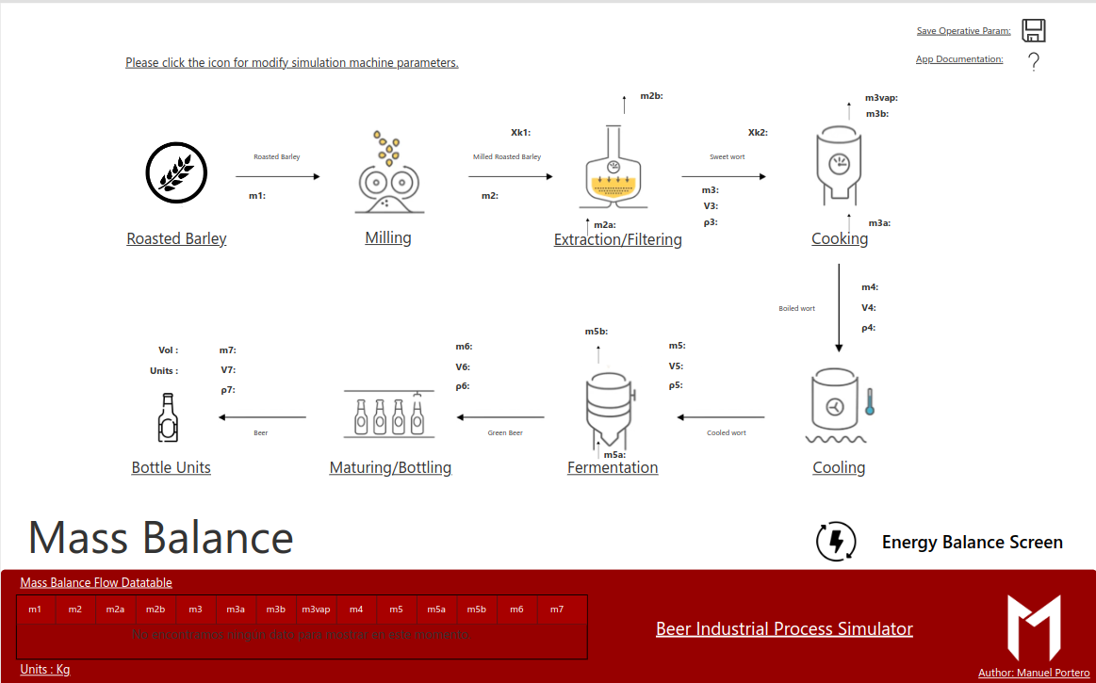
Picture 1: Beer Reactor Simulation Layout

Architecture
The composition of the architecture starts in the PowerApp. Once an equipment design is choosen an equipment design screen is shown, the user modify the equipment and after change the equipment parameters all the process is recalculared via PowerAutomate / Function app.

A full diagram of the solution is shown below.


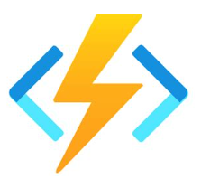
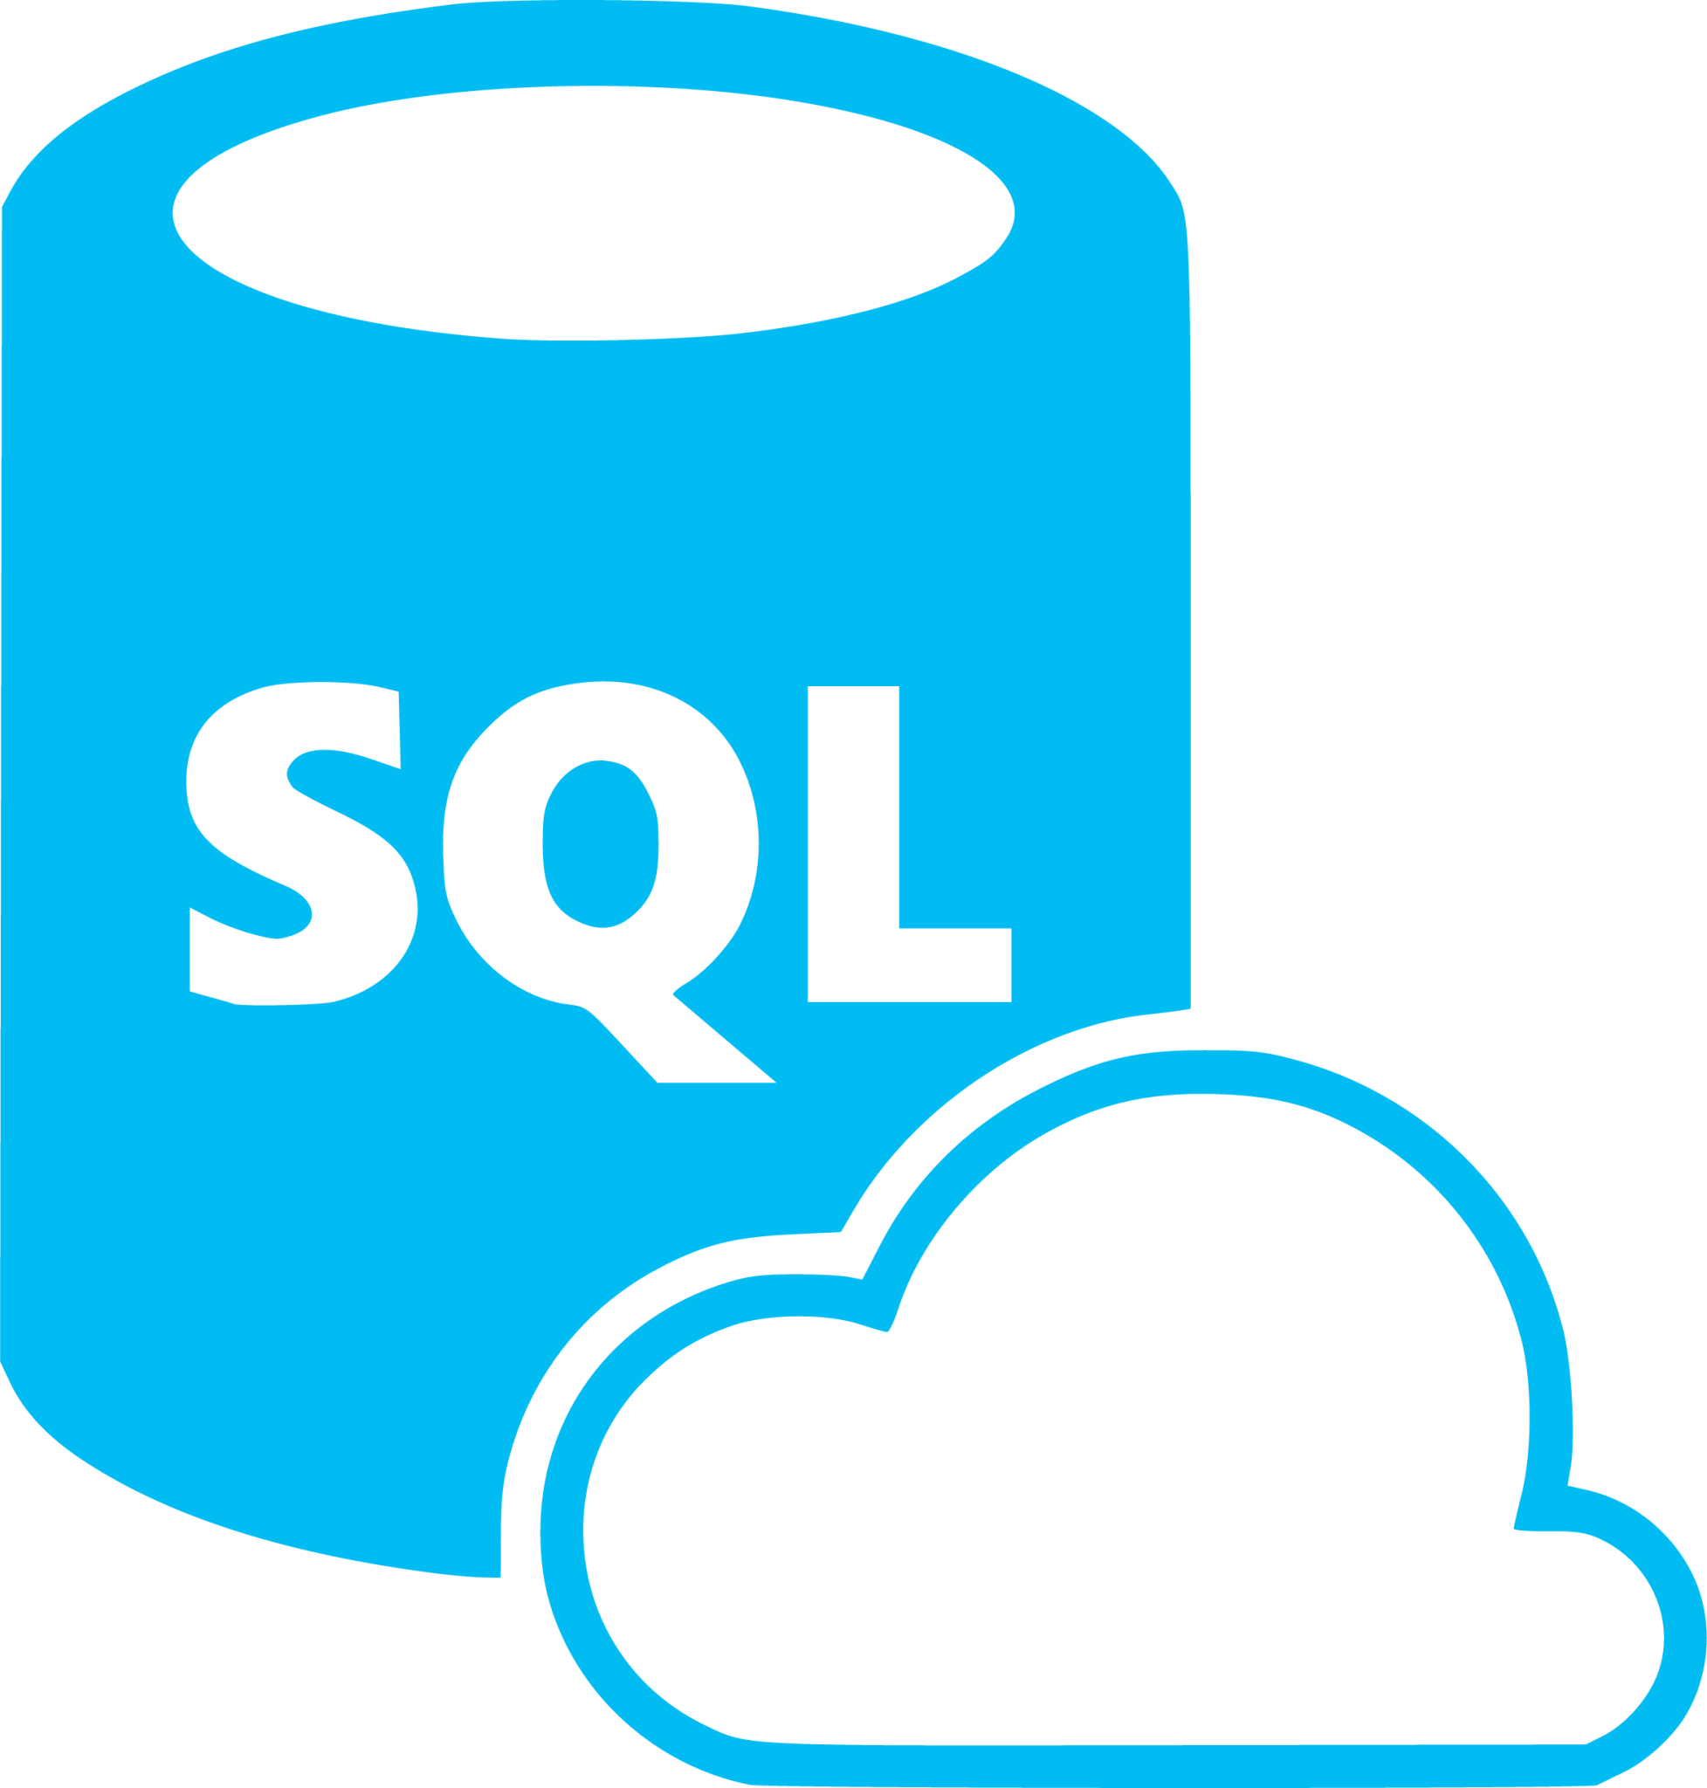

Picture 2: Beer Process Simulation Architecture

PowerApp

Main Screen
The main screen is composed by the mass balance of the beer process and the navigation buttons to the others screens.

Picture 4: S Beer Process Simulation main Screen

Equipment Screen
The Equipment Screen is composed by the different equipment parameter’s and a Equipment design diagram, we modify the key recalculation parameters in order to optimize the equpment design.

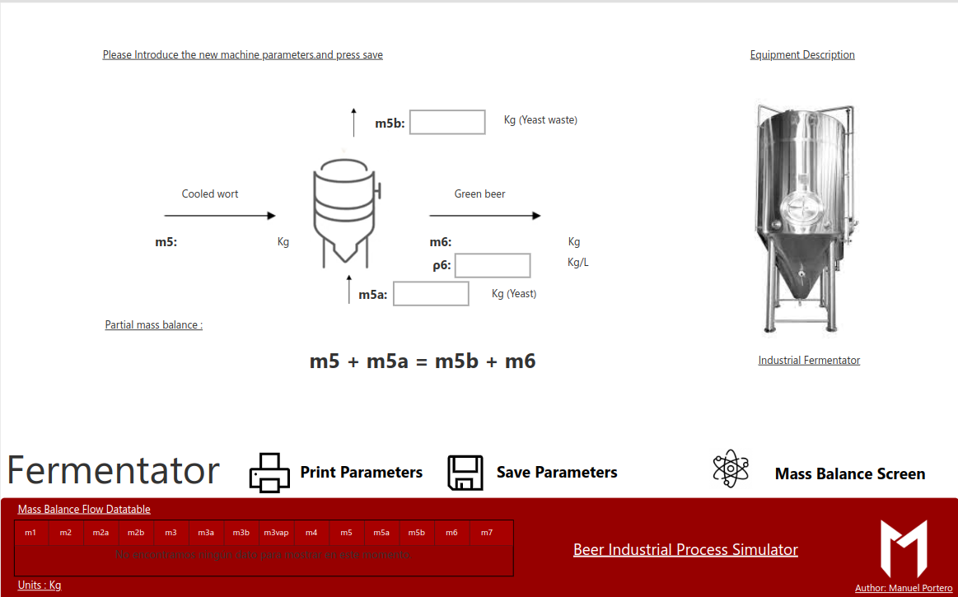
Picture 5: Equpmets Screen
Energy Balance Screen
The energy balance screen is composed by the full process energy balance parameters. The user can modify the heat exchange parameters in order to balance the whole energy balance after modifying the mass balance.
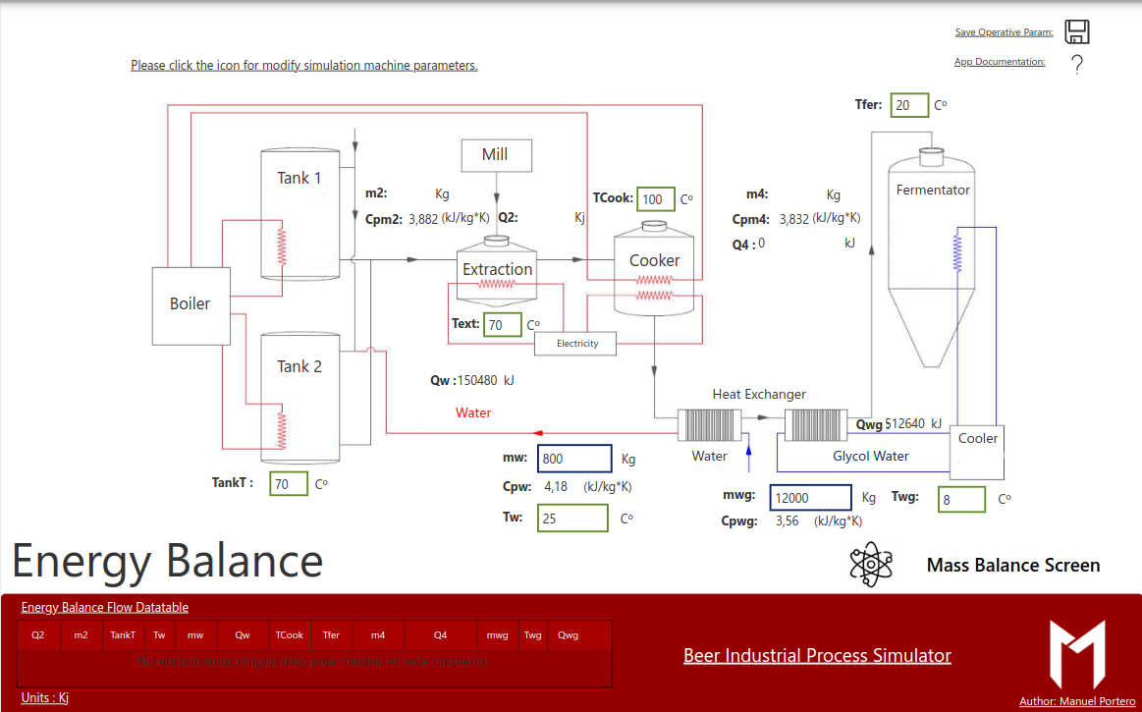
Picture 6: Energy Balance Screen

PowerAutomate Flow
The PowerAutomate flow receive the paremeters from the PowerApp clear, the SQL destination table, call the Azure function with an Http Request action and update again the table with the balance outputs parameters
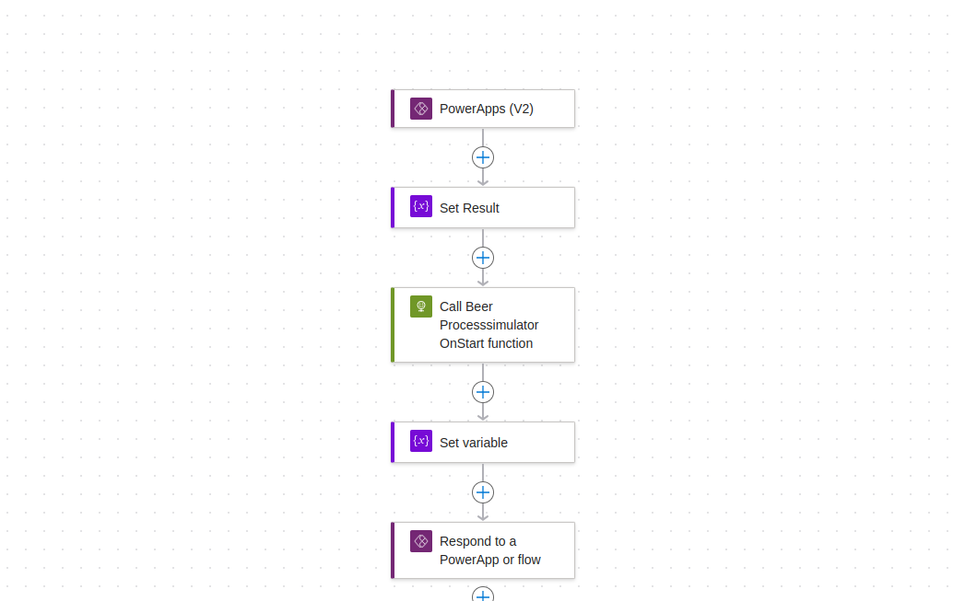
Picture 6: Beer Process Simualtion Flow Sample

Azure Function
The Process Design azure functions will receive the parameters from the PowerAutomate flow and will calculate the Volume and other design parameters of the choosen reactor. The code of each azure functions are shown below :

Beer Process Simulator Simulate

import json
import logging
import azure.functions as func
import numpy as np
import pyodbc

def main(req: func.HttpRequest) -> func.HttpResponse:
logging.info('BeerProcessSimulatorSimulate trigger function processed a request...')

# SQL database variables declaration

server = 'beerprocesssimulatorsql.database.windows.net'
database = 'BeerProcessSimulatorSQL'
username = 'titansax'
password = 'SecretoGlasgow11!'
drivers = [item for item in pyodbc.drivers()]
driver = drivers[-1]
logging.info("driver:{}".format(driver))

#Create a connection string

cnxn = pyodbc.connect('DRIVER='+driver+';SERVER='+server+';DATABASE='+database+';UID='+username+';PWD='+ password)
cursor = cnxn.cursor()

# Query Variables

try:
select_query = 'SELECT TOP 1 * FROM [dbo].[MassBalanceSimulated]'
cursor.execute(select_query)
data = cursor.fetchall()
logging.info(data)
except:
cnxn.rollback()
finally:
cnxn.commit()
cnxn.close()

# Variable declarations

Xk1 = data[0][0]

logging.info("Xk1 : " + str(Xk1))

Xk2 = data[0][1]

logging.info("Xk2 : " + str(Xk2))

m1 = data[0][2]

logging.info("m1 : " + str(m1))

m2 = data[0][3]

logging.info("m2 : " + str(m2))

m2b = data[0][4]

logging.info("m2b : " + str(m2b))

m3 = data[0][5]

logging.info("m3 : " + str(m3))

V3 = data[0][6]

logging.info("V3 : " + str(V3))

rho3 = data[0][7]

logging.info("rho3 : " + str(rho3))

m2a = data[0][8]

logging.info("m2a : " + str(m2a))

m3vap = data[0][9]

logging.info("m3vap : " + str(m3vap))

m3a = data[0][10]

logging.info("m3a : " + str(m3a))

m3b = data[0][11]

logging.info("m3b : " + str(m3b))

m4 = data[0][12]

logging.info("m4 : " + str(m4))

V4 = data[0][13]

logging.info("V4 : " + str(V4))

rho4 = data[0][14]

logging.info("rho4 : " + str(rho4))

m5 = data[0][15]

logging.info("m5 : " + str(m5))

V5 = data[0][16]

logging.info("V5 : " + str(V5))

rho5 = data[0][17]

logging.info("rho5 : " + str(rho5))

m5b = data[0][18]

logging.info("m5b : " + str(m5b))

V5b = data[0][19]

logging.info("V5b : " + str(V5b))

m6 = data[0][20]

logging.info("m6 : " + str(m6))

V6 = data[0][21]

logging.info("V6 : " + str(V6))

rho6 = data[0][22]

logging.info("rho6 : " + str(rho6))

m5a = data[0][23]

logging.info("m5b : " + str(m5b))

m7 = data[0][24]

logging.info("m7 : " + str(m7))

V7 = data[0][25]

logging.info("V7 : " + str(V7))

rho7 = data[0][26]

logging.info("rho7 : " + str(rho7))

Vol = data[0][27]

logging.info("Vol : " + str(Vol))

TimeDate = data[0][28]

logging.info("TimeDate : " + str(TimeDate))

# Mass Balance

# Step 1 : Milling

m2 = m1

logging.info("m2 : " + str(m2))

# Step 2 : Extraction

m2b = Xk1 / m2

logging.info("m2b : " + str(m2b))

m3 = m2 + m2a - m2b

logging.info("m3 : " + str(m3))

# Step 3 : Cooking

m3b = m3a * Xk2

logging.info("m3b : " + str(m3b))

m4 = m3 + m3a - m3b - m3vap

logging.info("m4 : " + str(m4))

V3 = m3 / rho3

logging.info("V3 : " + str(V3))

V4 = m4 / rho4

logging.info("V4 : " + str(V4))

# Cooling

m5 = m4

logging.info("m5 : " + str(m5))

# Fermentation

m6 = m5 + m5a - m5b

logging.info("m6 : " + str(m6))

V5b = m5b / rho5

logging.info("V5b : " + str(V5b))

# Maturing and bottling

m7 = m6

logging.info("m7 : " + str(m7))

V7 = m7/rho7

logging.info("V7 : " + str(V7))

#Insert Query

#Create a connection string

cnxn = pyodbc.connect('DRIVER='+driver+';SERVER='+server+';DATABASE='+database+';UID='+username+';PWD='+ password)
cursor = cnxn.cursor()

try:
delete_query = "DELETE TOP (1) FROM [dbo].[MassBalanceSimulated]"
cursor.execute(delete_query)
insert_query ="INSERT INTO [dbo].[MassBalanceSimulated] ([Xk1],[Xk2],[m1],[m2],[m2b],[m3],[V3],[rho3],[m2a],[m3vap],[m3a],[m3b],[m4],[V4],[rho4],[m5],[V5],[rho5],[m5b],[V5b],[m6],[V6],[rho6],[m5a],[m7],[V7],[rho7],[Vol],[TimeDate]) VALUES (?,?,?,?,?,?,?,?,?,?,?,?,?,?,?,?,?,?,?,?,?,?,?,?,?,?,?,?,?)"
cursor.execute(insert_query,Xk1,Xk2,m1,m2,m2b,m3,V3,rho3,m2a,m3vap,m3a,m3b,m4,V4,rho4,m5,V5,rho5,m5b,V5b,m6,V6,rho6,m5a,m7,V7,rho7,Vol,TimeDate)
except:
cnxn.rollback()
finally:
cnxn.commit()
cnxn.close()

return func.HttpResponse(
"BeerProcessSimulatorSimulate function executed successfully.",
status_code=200
)

Beer Process Simulator - Mass Balance

import datetime
import json
import logging
import azure.functions as func
import numpy as np
import pyodbc

def main(mytimer: func.TimerRequest) -> None:
utc_timestamp = datetime.datetime.utcnow().replace(
tzinfo=datetime.timezone.utc).isoformat()

# SQL database variables declaration

server = 'beerprocesssimulatorsql.database.windows.net'
database = 'BeerProcessSimulatorSQL'
username = 'titansax'
password = 'SecretoGlasgow11!'
drivers = [item for item in pyodbc.drivers()]
driver = drivers[-1]
logging.info("driver:{}".format(driver))

#Create a connection string

cnxn = pyodbc.connect('DRIVER='+driver+';SERVER='+server+';DATABASE='+database+';UID='+username+';PWD='+ password)
cursor = cnxn.cursor()

# Query Variables

try:
select_query = 'SELECT TOP 1 * FROM [dbo].[MassBalance]'
cursor.execute(select_query)
data = cursor.fetchall()
logging.info(data)
except:
cnxn.rollback()
finally:
cnxn.commit()
cnxn.close()

# Variable declarations

Xk1 = data[0][0]

logging.info("Xk1 : " + str(Xk1))

Xk2 = data[0][1]

logging.info("Xk2 : " + str(Xk2))

m1 = data[0][2]

logging.info("m1 : " + str(m1))

m2 = data[0][3]

logging.info("m2 : " + str(m2))

m2b = data[0][4]

logging.info("m2b : " + str(m2b))

m3 = data[0][5]

logging.info("m3 : " + str(m3))

V3 = data[0][6]

logging.info("V3 : " + str(V3))

rho3 = data[0][7]

logging.info("rho3 : " + str(rho3))

m2a = data[0][8]

logging.info("m2a : " + str(m2a))

m3vap = data[0][9]

logging.info("m3vap : " + str(m3vap))

m3a = data[0][10]

logging.info("m3a : " + str(m3a))

m3b = data[0][11]

logging.info("m3b : " + str(m3b))

m4 = data[0][12]

logging.info("m4 : " + str(m4))

V4 = data[0][13]

logging.info("V4 : " + str(V4))

rho4 = data[0][14]

logging.info("rho4 : " + str(rho4))

m5 = data[0][15]

logging.info("m5 : " + str(m5))

V5 = data[0][16]

logging.info("V5 : " + str(V5))

rho5 = data[0][17]

logging.info("rho5 : " + str(rho5))

m5b = data[0][18]

logging.info("m5b : " + str(m5b))

V5b = data[0][19]

logging.info("V5b : " + str(V5b))

m6 = data[0][20]

logging.info("m6 : " + str(m6))

V6 = data[0][21]

logging.info("V6 : " + str(V6))

rho6 = data[0][22]

logging.info("rho6 : " + str(rho6))

m5a = data[0][23]

logging.info("m5b : " + str(m5b))

m7 = data[0][24]

logging.info("m7 : " + str(m7))

V7 = data[0][25]

logging.info("V7 : " + str(V7))

rho7 = data[0][26]

logging.info("rho7 : " + str(rho7))

Vol = data[0][27]

logging.info("Vol : " + str(Vol))

TimeDate = data[0][28]

logging.info("TimeDate : " + str(TimeDate))

# Mass Balance

# Step 1 : Milling

m2 = m1

logging.info("m2 : " + str(m2))

# Step 2 : Extraction

m2b = Xk1 / m2

logging.info("m2b : " + str(m2b))

m3 = m2 + m2a - m2b

logging.info("m3 : " + str(m3))

# Step 3 : Cooking

m3b = m3a * Xk2

logging.info("m3b : " + str(m3b))

m4 = m3 + m3a - m3b - m3vap

logging.info("m4 : " + str(m4))

V3 = m3 / rho3

logging.info("V3 : " + str(V3))

V4 = m4 / rho4

logging.info("V4 : " + str(V4))

# Cooling

m5 = m4

logging.info("m5 : " + str(m5))

# Fermentation

m6 = m5 + m5a - m5b

logging.info("m6 : " + str(m6))

V5b = m5b / rho5

logging.info("V5b : " + str(V5b))

# Maturing and bottling

m7 = m6

logging.info("m7 : " + str(m7))

V7 = m7/rho7

logging.info("V7 : " + str(V7))

#Insert Query

#Create a connection string

cnxn = pyodbc.connect('DRIVER='+driver+';SERVER='+server+';DATABASE='+database+';UID='+username+';PWD='+ password)
cursor = cnxn.cursor()

try:

insert_query ="INSERT INTO [dbo].[MassBalance] ([Xk1],[Xk2],[m1],[m2],[m2b],[m3],[V3],[rho3],[m2a],[m3vap],[m3a],[m3b],[m4],[V4],[rho4],[m5],[V5],[rho5],[m5b],[V5b],[m6],[V6],[rho6],[m5a],[m7],[V7],[rho7],[Vol],[TimeDate]) VALUES (?,?,?,?,?,?,?,?,?,?,?,?,?,?,?,?,?,?,?,?,?,?,?,?,?,?,?,?,?)"
cursor.execute(insert_query,Xk1,Xk2,m1,m2,m2b,m3,V3,rho3,m2a,m3vap,m3a,m3b,m4,V4,rho4,m5,V5,rho5,m5b,V5b,m6,V6,rho6,m5a,m7,V7,rho7,Vol,str(utc_timestamp)[0:19])
except:
cnxn.rollback()
finally:
cnxn.commit()
cnxn.close()

logging.info("dateTime : " + str(utc_timestamp)[0:19])
logging.info('BeerProcessSimulator function executed successfully at %s', utc_timestamp)

Beer Process Simulator – On start

import datetime
import json
import logging
import azure.functions as func
import numpy as np
import pyodbc

def main(req: func.HttpRequest) -> func.HttpResponse:
logging.info('BeerProcessSimulatorSimulate trigger function processed a request...')

# SQL database variables declaration

server = 'beerprocesssimulatorsql.database.windows.net'
database = 'BeerProcessSimulatorSQL'
username = 'titansax'
password = 'SecretoGlasgow11!'
drivers = [item for item in pyodbc.drivers()]
driver = drivers[-1]
logging.info("driver:{}".format(driver))

#Create a connection string

cnxn = pyodbc.connect('DRIVER='+driver+';SERVER='+server+';DATABASE='+database+';UID='+username+';PWD='+ password)
cursor = cnxn.cursor()

# Query Variables

try:
select_query = 'SELECT TOP 1 * FROM [dbo].[MassBalanceSimulated] ORDER BY TimeDate DESC'
cursor.execute(select_query)
data = cursor.fetchall()
logging.info(data)
except:
cnxn.rollback()
finally:
cnxn.commit()
cnxn.close()

# Variable declarations

Xk1 = data[0][0]

logging.info("Xk1 : " + str(Xk1))

Xk2 = data[0][1]

logging.info("Xk2 : " + str(Xk2))

m1 = data[0][2]

logging.info("m1 : " + str(m1))

m2 = data[0][3]

logging.info("m2 : " + str(m2))

m2b = data[0][4]

logging.info("m2b : " + str(m2b))

m3 = data[0][5]

logging.info("m3 : " + str(m3))

V3 = data[0][6]

logging.info("V3 : " + str(V3))

rho3 = data[0][7]

logging.info("rho3 : " + str(rho3))

m2a = data[0][8]

logging.info("m2a : " + str(m2a))

m3vap = data[0][9]

logging.info("m3vap : " + str(m3vap))

m3a = data[0][10]

logging.info("m3a : " + str(m3a))

m3b = data[0][11]

logging.info("m3b : " + str(m3b))

m4 = data[0][12]

logging.info("m4 : " + str(m4))

V4 = data[0][13]

logging.info("V4 : " + str(V4))

rho4 = data[0][14]

logging.info("rho4 : " + str(rho4))

m5 = data[0][15]

logging.info("m5 : " + str(m5))

V5 = data[0][16]

logging.info("V5 : " + str(V5))

rho5 = data[0][17]

logging.info("rho5 : " + str(rho5))

m5b = data[0][18]

logging.info("m5b : " + str(m5b))

V5b = data[0][19]

logging.info("V5b : " + str(V5b))

m6 = data[0][20]

logging.info("m6 : " + str(m6))

V6 = data[0][21]

logging.info("V6 : " + str(V6))

rho6 = data[0][22]

logging.info("rho6 : " + str(rho6))

m5a = data[0][23]

logging.info("m5b : " + str(m5b))

m7 = data[0][24]

logging.info("m7 : " + str(m7))

V7 = data[0][25]

logging.info("V7 : " + str(V7))

rho7 = data[0][26]

logging.info("rho7 : " + str(rho7))

Vol = data[0][27]

logging.info("Vol : " + str(Vol))

TimeDate = data[0][28]

logging.info("TimeDate : " + str(TimeDate))

utc_timestamp = datetime.datetime.utcnow().replace(tzinfo=datetime.timezone.utc).isoformat()

logging.info(str(utc_timestamp)[0:19])
#Insert Query

#Create a connection string

cnxn = pyodbc.connect('DRIVER='+driver+';SERVER='+server+';DATABASE='+database+';UID='+username+';PWD='+ password)
cursor = cnxn.cursor()

try:
insert_query ="INSERT INTO [dbo].[MassBalance] ([Xk1],[Xk2],[m1],[m2],[m2b],[m3],[V3],[rho3],[m2a],[m3vap],[m3a],[m3b],[m4],[V4],[rho4],[m5],[V5],[rho5],[m5b],[V5b],[m6],[V6],[rho6],[m5a],[m7],[V7],[rho7],[Vol],[TimeDate]) VALUES (?,?,?,?,?,?,?,?,?,?,?,?,?,?,?,?,?,?,?,?,?,?,?,?,?,?,?,?,?)"
cursor.execute(insert_query,Xk1,Xk2,m1,m2,m2b,m3,V3,rho3,m2a,m3vap,m3a,m3b,m4,V4,rho4,m5,V5,rho5,m5b,V5b,m6,V6,rho6,m5a,m7,V7,rho7,Vol,str(utc_timestamp)[0:19])
except:
cnxn.rollback()
finally:
cnxn.commit()
cnxn.close()

return func.HttpResponse(
"BeerProcessSimulatorSaveConfig function executed successfully.",
status_code=200
)

Beer Process Simulator – On Start

import json
import logging
import azure.functions as func
import numpy as np
import pyodbc

def main(req: func.HttpRequest) -> func.HttpResponse:
logging.info('BeerProcessSimulatorSimulate trigger function processed a request...')

# SQL database variables declaration

server = 'beerprocesssimulatorsql.database.windows.net'
database = 'BeerProcessSimulatorSQL'
username = 'titansax'
password = 'SecretoGlasgow11!'
drivers = [item for item in pyodbc.drivers()]
driver = drivers[-1]
logging.info("driver:{}".format(driver))

#Create a connection string

cnxn = pyodbc.connect('DRIVER='+driver+';SERVER='+server+';DATABASE='+database+';UID='+username+';PWD='+ password)
cursor = cnxn.cursor()

# Query Variables

try:
select_query = 'SELECT TOP 1 * FROM [dbo].[MassBalance] ORDER BY TimeDate DESC'
cursor.execute(select_query)
data = cursor.fetchall()
logging.info(data)
except:
cnxn.rollback()
finally:
cnxn.commit()
cnxn.close()

# Variable declarations

Xk1 = data[0][0]

logging.info("Xk1 : " + str(Xk1))

Xk2 = data[0][1]

logging.info("Xk2 : " + str(Xk2))

m1 = data[0][2]

logging.info("m1 : " + str(m1))

m2 = data[0][3]

logging.info("m2 : " + str(m2))

m2b = data[0][4]

logging.info("m2b : " + str(m2b))

m3 = data[0][5]

logging.info("m3 : " + str(m3))

V3 = data[0][6]

logging.info("V3 : " + str(V3))

rho3 = data[0][7]

logging.info("rho3 : " + str(rho3))

m2a = data[0][8]

logging.info("m2a : " + str(m2a))

m3vap = data[0][9]

logging.info("m3vap : " + str(m3vap))

m3a = data[0][10]

logging.info("m3a : " + str(m3a))

m3b = data[0][11]

logging.info("m3b : " + str(m3b))

m4 = data[0][12]

logging.info("m4 : " + str(m4))

V4 = data[0][13]

logging.info("V4 : " + str(V4))

rho4 = data[0][14]

logging.info("rho4 : " + str(rho4))

m5 = data[0][15]

logging.info("m5 : " + str(m5))

V5 = data[0][16]

logging.info("V5 : " + str(V5))

rho5 = data[0][17]

logging.info("rho5 : " + str(rho5))

m5b = data[0][18]

logging.info("m5b : " + str(m5b))

V5b = data[0][19]

logging.info("V5b : " + str(V5b))

m6 = data[0][20]

logging.info("m6 : " + str(m6))

V6 = data[0][21]

logging.info("V6 : " + str(V6))

rho6 = data[0][22]

logging.info("rho6 : " + str(rho6))

m5a = data[0][23]

logging.info("m5b : " + str(m5b))

m7 = data[0][24]

logging.info("m7 : " + str(m7))

V7 = data[0][25]

logging.info("V7 : " + str(V7))

rho7 = data[0][26]

logging.info("rho7 : " + str(rho7))

Vol = data[0][27]

logging.info("Vol : " + str(Vol))

TimeDate = data[0][28]

logging.info("TimeDate : " + str(TimeDate))

#Insert Query

#Create a connection string

cnxn = pyodbc.connect('DRIVER='+driver+';SERVER='+server+';DATABASE='+database+';UID='+username+';PWD='+ password)
cursor = cnxn.cursor()

try:
delete_query = "DELETE TOP (1) FROM [dbo].[MassBalanceSimulated]"
cursor.execute(delete_query)
insert_query ="INSERT INTO [dbo].[MassBalanceSimulated] ([Xk1],[Xk2],[m1],[m2],[m2b],[m3],[V3],[rho3],[m2a],[m3vap],[m3a],[m3b],[m4],[V4],[rho4],[m5],[V5],[rho5],[m5b],[V5b],[m6],[V6],[rho6],[m5a],[m7],[V7],[rho7],[Vol],[TimeDate]) VALUES (?,?,?,?,?,?,?,?,?,?,?,?,?,?,?,?,?,?,?,?,?,?,?,?,?,?,?,?,?)"
cursor.execute(insert_query,Xk1,Xk2,m1,m2,m2b,m3,V3,rho3,m2a,m3vap,m3a,m3b,m4,V4,rho4,m5,V5,rho5,m5b,V5b,m6,V6,rho6,m5a,m7,V7,rho7,Vol,TimeDate)
except:
cnxn.rollback()
finally:
cnxn.commit()
cnxn.close()

return func.HttpResponse(
"BeerProcessSimulator_OnStartApp function executed successfully.",
status_code=200
)

